Exploring Blueprint
Main features:
1. Adding application context
2. Adding requirements so that workflows will be created based on that
3. New casetype design and data model design will be created. They will be customizable.
4. Ability to add in new personas.
5. Summary page where we will be able to download the blueprint as well as the PDF file consolidating whatever generated.
Additional features:
1. Ability to add supporting assets – requirement documents, legacy application media,
data schema and integrations – different format – DDL, OpenAPI
Process diagrams – bpmn , jpg or jpeg
Code analysis document – AWS Transform, Google MAT
Additional assets like blueprint
Build from blueprint
- Customisation of classes, application name and all possible using customize button for blueprint
Keylearnings alongside:
1. For generating PDFs in constellation, we should use custom sections. But the constellation build generates only views by default. So, you need to create sections separately
2. Manually creating flow action and using view which is already created for it.
Refer: https://docs.pega.com/bundle/platform/page/platform/case-management/aligning-views-to-flow-actions-through-naming.html
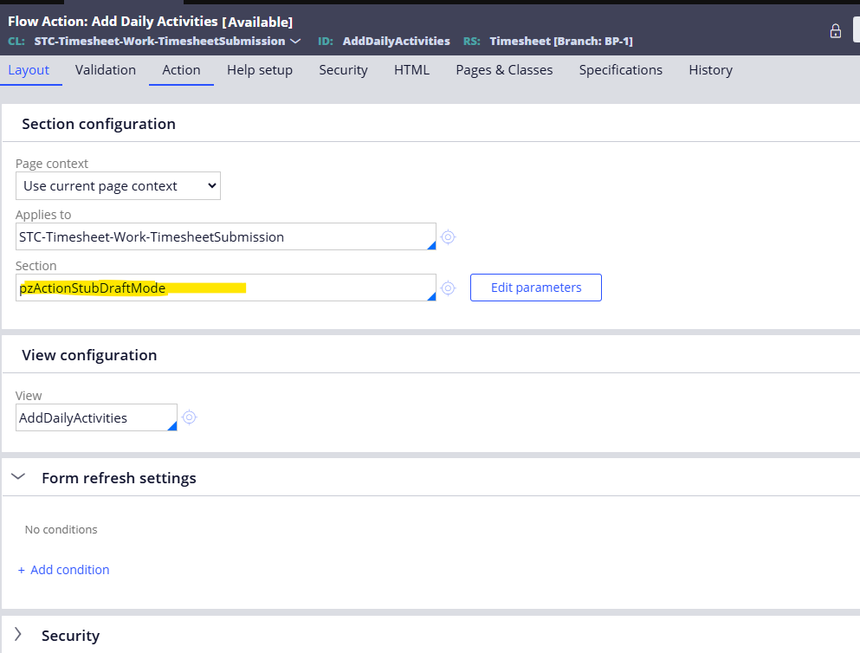
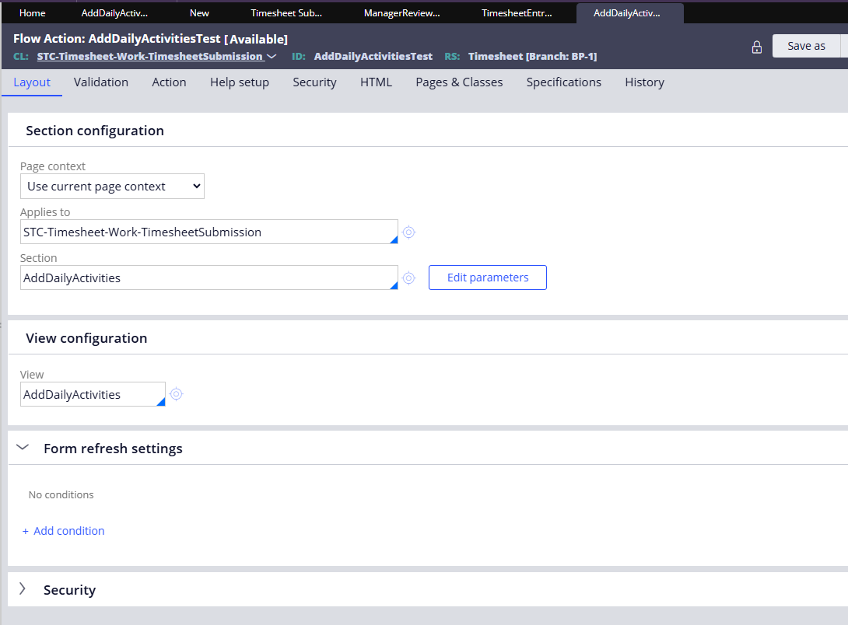

3. Views configuration
https://support.pega.com/discussion/views-configuration

